PUPIL PREMIUM REPORT
July 2014

Introduction
The primary focus of the previous two pupil premium reports was the academic progress that the pupil premium children had made in Reading, Writing and Numeracy and how the progress was influenced by the work that the pupil premium teaching assistant carried out.
Progress is one measure of a child’s learning, where learning is defined as the application of specific knowledge and skills. There are many factors that may impact on a child’s ability to learn including teaching, friendships, personal motivation/attitude, a child’s feeling of self-worth and their home life. This report focusses on the school’s Lunch Club. The Lunch Club is one of the ways in which pupil premium funding is being spent to address those more elusive and numerically unquantifiable, but no less important, social and emotional factors that affect a child’s progress.

Why provide a Lunch Club?
In May 2012 it became apparent that there was a small group of children for whom the lunch hour was a difficult and challenging time. There were three main reasons for this:
- The children were emotionally vulnerable.
- The children had specific issues, for example fall-outs within friendship groups, which significantly impacted the child during the lunch period.
- The child found socialising for the whole of the lunch hour a challenging experience which, in consequence, led to deterioration in the child’s behaviour and conflict with peers.
Therefore the Lunch Club was set up for these children with the aim of providing a safe and engaging environment where a child’s social and emotional needs could be better met.

How does the Lunch Club Work?
The lunch club is run by the Pupil Premium Teaching Assistant and children are referred to the club by herself, or by the mid-day supervisors, teachers or teaching assistants.
Currently there are three Lunch Club sessions per week with each session running from 12pm until 1pm. The children go to lunch at 12pm and come straight to the club after they have eaten.
Each child has a designated day on which they attend the club, however they are all also aware that if they are having a bad day the door of the lunch club is always open to them. Occasionally an attendee may also bring a friend to share the Lunch Club experiences with. During the summer term twenty-two children attended the Lunch Club.
The Pupil Premium Teaching Assistant generally runs the club alone, however due to a potentially volatile emotional mix at one of the clubs additional staff support was provided by Ms Blackmore.

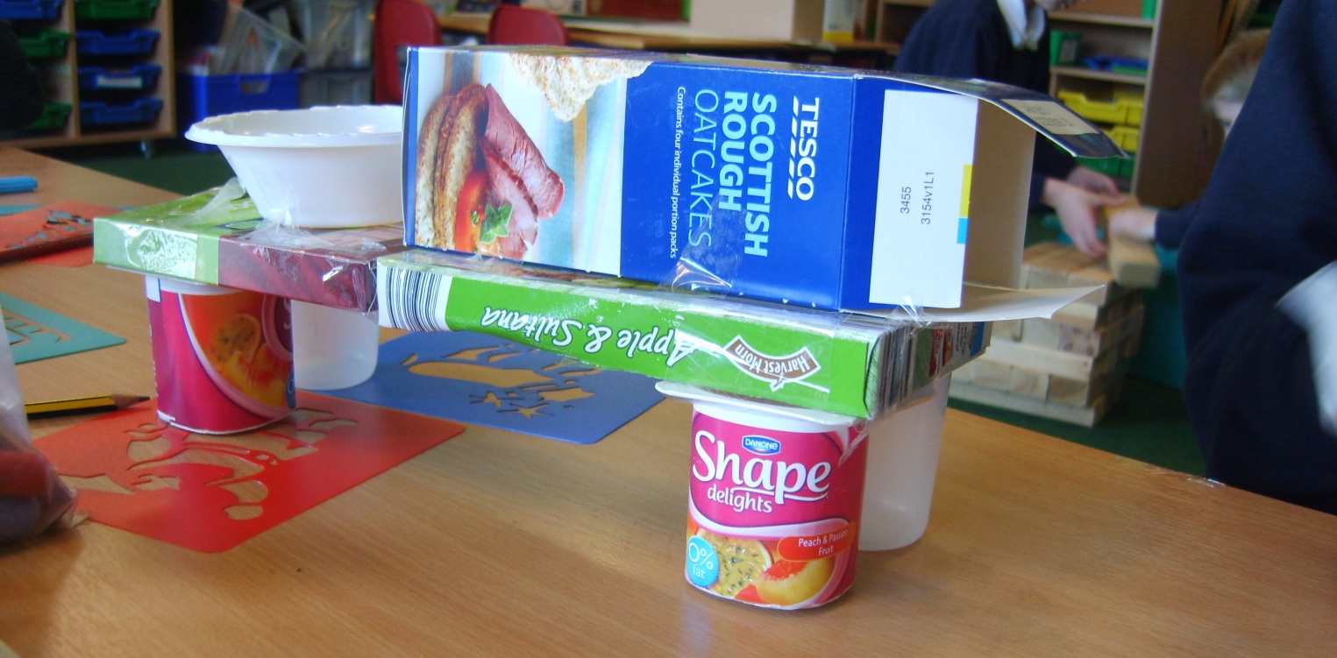

What does the Club Provide?
In terms of physical resources the club provides a number of activities for the children to take part in, including puppets for role play, books, games and creative pursuits such as seasonal craft activities.
The children’s social needs are supported in that they have free choice as to which activities they wish to take part in and whether they wish to play together or alone. An ethos of sharing is fostered, particularly where the fortnightly use of the laptop computers is concerned. Inter-year friendships are encouraged and older children may be given responsibility for younger members of the club when outside the club setting
Large floor cushions provide emotionally charged children with a safe and quiet space in which they can vent their emotions, chill out and seek comfort. Quality non-teaching time with adult contact is also provided for those that require it.

What do the Children Think?
The children that I spoke to regarding their time at lunch club were positive about their experiences and seemed to enjoy their time there. They looked forward to going. Attendance at the club made them feel safe and needed.
ALL the children sited playing on the computer as the thing they enjoyed most about the club. Another enjoyed playing draughts and much preferred lunch club to going outside as there “was nothing to do outside” and “you don’t get wet.”
Another child said that there was a lovely, friendly atmosphere at the club and that there was cool stuff to do - there were less people there and you could get on with your own stuff.

Conclusion
There is no doubt that Lunch Club provides a safe and interesting setting for the children to play together.
For some older children who found a lunch hour socially challenging just knowing that the club was there if they needed it was enough – they were emotionally aware enough to use the club as a quiet space to calm down before returning to the playground.
Ironically, the success of the club can be measured by those children who no longer attend. For some older children, once their particular social/emotional need was met they made a personal choice not to attend the club. They felt comfortable, confident and happy enough to spend the whole lunch hour on the playground instead.
From the conversations that I had with the children it is clear that the Lunch Club is quietly providing for their social and emotional needs and vulnerabilities, without them realising it.
Finally it is worth noting that because attendance at the Lunch Club is based on need, not all the children that currently attend the club are Pupil Premium Children, however if a need does arise the doors of the Lunch Club will always be open to them.

