Dear Parent/Carer

Learning from home just got more exciting with Espresso!

We are pleased to announce that you and your child can access the BAFTA award-winning Espresso Primary service at home.

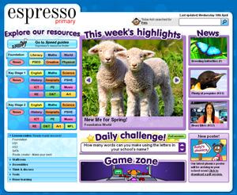
We use Espresso in school to help motivate, engage and support learning in the classroom. Now your child can continue to enjoy what they have been doing at school, and you can be involved in their learning at home.

About Espresso Primary
Espresso Primary is an online cross-curricular service that provides video-rich resources to schools throughout the UK. It contains thousands of videos and multimedia activities, as well as a weekly news service — all designed by teaching professionals. For more information, please visit: www.espresso.co.uk

Espresso Primary Home Access includes a Home learning area and Parents’ guide with information to help you use the service.

How to access Espresso from home
To access Espresso from home you will need a PC or Apple Mac and a connection to the internet. You can then go to https://online.espresso.co.uk and the school’s username: student24249 and the password: oswald.
Every child’s username and password is the same for Home Access.

If you have any trouble logging in or accessing Espresso from home, please contact Miss Ryan.

Getting started
Before you start using Espresso, read the Parents’ guide. This explains what Espresso is, how to use it and how to support your child with their learning. To find the guide, select one of the Home learning icons (from the appropriate key stage) on the left-hand side of the Espresso home page. The Parents’ guide button is located in the top left-hand corner of the following page.

Your child should already be familiar with Espresso. They could show you how they have been using it in class and how to find resources. Once you are familiar with the service, you and your child may like to explore Espresso’s modules or the Home learning area. Specifically designed for home use, it includes easy-to-follow Learning paths and curriculum objectives.

We hope you will find Espresso useful as a resource to extend your child’s learning. If you have any further questions about how to use the service, please speak to your child’s teacher.

Kind regards
Miss Ryan

ICT Coordinator

