November 2014

EARLY YEARS NEWS

[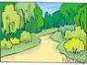](http://www.google.co.uk/url?q=http://www.graphicsfactory.com/search/landscape-p1.html&sa=U&ei=6HFXVIj-J5PKaOaIgIgM&ved=0CCgQ9QEwCTgU&usg=AFQjCNG6B8SJfYVpbwerGJdt61usvFVUEA)

Our topic for this half-term is “In the woods”. We will read lots of stories set in the woods and explore the characters in them. We are hoping to make a trip to a local wood and we will investigate the different plants and animals that live there. We will also learn about Bonfire Night and the traditions associated with Christmas. You can help by collecting things from any woods you visit for our display.

[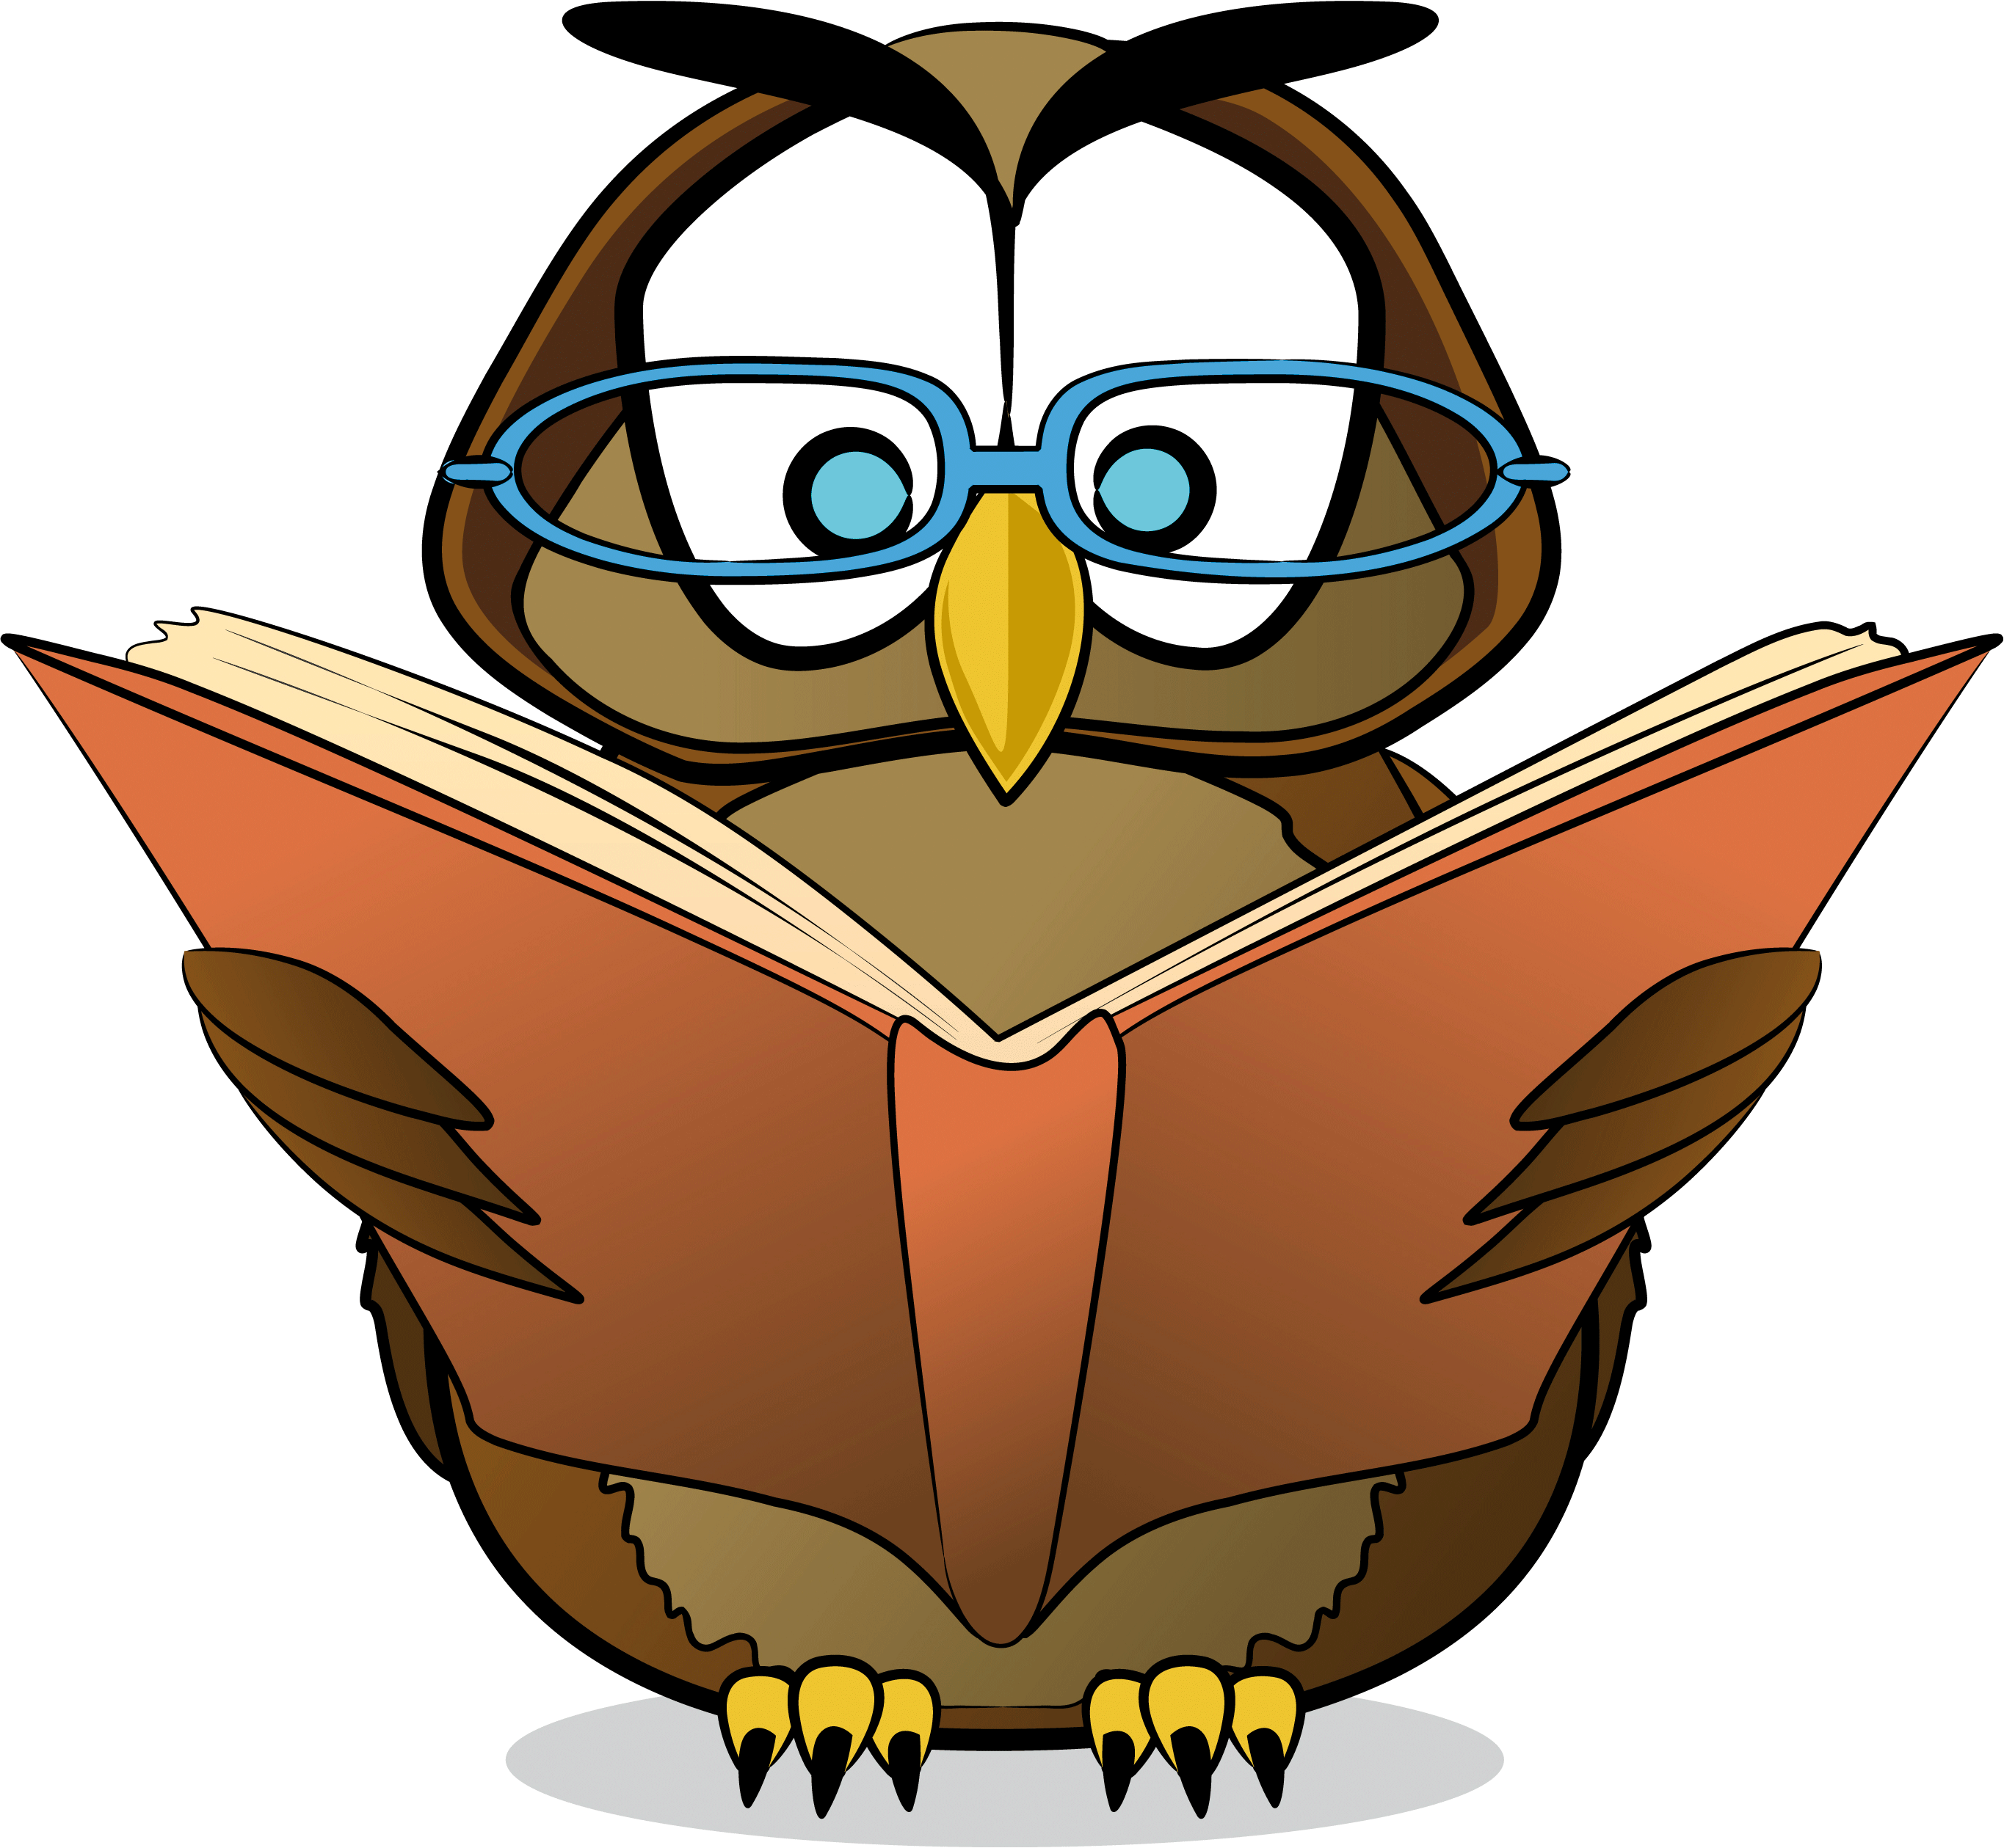](http://www.google.co.uk/url?sa=i&rct=j&q=&esrc=s&frm=1&source=images&cd=&cad=rja&docid=VZJWAMmxLxPkMM&tbnid=MQTsH68ecfcC8M:&ved=0CAUQjRw&url=http://www.bubblews.com/news/714513-books-recommendation&ei=owF5Us2vMIXt0gXDkoHYCA&bvm=bv.55980276,d.ZG4&psig=AFQjCNGzyd8jc0VCfgf0FeRZ4F-dcUgLzg&ust=1383748366139032)In Literacy we will be reading lots of different stories set in the woods. We will learn to retell them, to talk about the characters and to make up our own versions. We will use information texts to find out about woodland animals and will learn to write firework words, recipes for potions and labels and captions for pictures.

[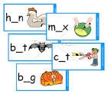](http://www.google.co.uk/url?q=http://www.teachthis.com/products/view-resource/link/CVC-Words-Missing-Vowel-Activity/id/234/&sa=U&ei=tzgtVLbjH9Xdarv9gqAH&ved=0CCIQ9QEwBg&usg=AFQjCNG0NaSUf1Ruw9rj_gcqIdJrVfRy8g)In Phonics we will learn the final sounds from the alphabet and then we will learn what happens when 2 letters are needed to make a sound. We will continue to practise blending sounds together to read words and segmenting words into their separate sounds to spell them. We will then learn to read and write simple sentences. You can help at home by practising the new sounds.

Once your child brings home a reading book, please try and practise with them every night to help with fluency. Please continue to practise key words regularly as well.

[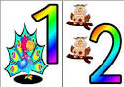](http://www.google.co.uk/url?q=http://www.instantdisplay.co.uk/number.htm&sa=U&ei=gDgtVN_-As3hat2vgPAD&ved=0CC4Q9QEwDA&usg=AFQjCNHG650dBaD_GzF4T6MfKeGuzwy5zw)In maths we will learn to find 1 more or 1 less than a number really quickly and to order numbers to 20 and beyond. We will start counting in 2s and 10s and will learn to write all our numerals to 9 as well as reading numbers to 20. We will also learn to add numbers by counting on and to subtract them by counting back.

**Our key target is for all children to know 1 more and 1 less than any number to 10 (or beyond if they can do this) so please try and practise this regularly at home.**

Bits & Bobs

The children will start to bring reading books home as soon as they are ready. We will hear them read in school twice a week and will change books on Tuesdays and Fridays. Please make sure books are in school every day as we use any additional adult help to hear children read when we can. If you would like to help with this, please let us know.

Our Nativity will take place on Tuesday 16th December at 2.15pm.

Please make sure children always have a coat in school.