Dear Parents/Carers,

This term St Oswald’s Primary has subscribed to Purple Mash, an exciting and safe online environment where children can get involved in all sorts of creative projects to support their learning in Literacy, Maths, Science, ICT, History, Geography, RE, Art, Music, and Design and Technology.

All KS2 pupils now have their Username and Password to access their Purple Mash account from home. Each child has their own personal login, which is unique to them and will enable them to access the different activities Purple Mash has to offer. KS1 and Reception Pupils can access Purple Mash using the login: pupil and the password: 1234

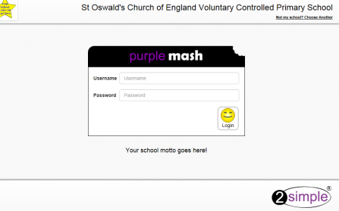
There is a link on the school website to access Purple Mash. Complete the login by adding your child’s username at the beginning of the details that appear, and their password. They have been given a login card and they need to keep this safe at home as it has their unique details on it. If children need to access their account at school and cannot remember their login, class teachers will have a list of these in school.

You can also access the Purple Mash website using the following address:
http://www.purplemash.co.uk/stoswaldsyo10

Hopefully this letter gives you an exciting insight into Purple Mash and the ways we hope it can be used both in school and at home. Please feel free to browse the site at your own leisure using your child’s login and if you have any questions, queries or problems, please ask.
We hope that you will enjoy using Purple Mash

Many thanks,

Miss Ryan

