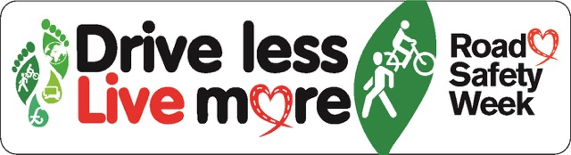

20th November 2015
Dear Parent / Carer

Safe travel to school – we need your help!

This year St Oswald’s is taking part in national ‘Road Safety Week’, which runs from 23-27 November. We will be using this to reinforce important safety messages with the children, such as how to cross roads safely and stay safe on a bike, and following up the excellent ‘HGV Awareness’ training delivered by Gist to pupils in KS2 this week.

As you can see the theme this year is ‘Drive less, Live more,’ a message which is obviously aimed mainly at adults. Like many schools we have ongoing problems due to the number of pupils travelling to and from school by car, and particularly the inconsiderate or unsafe behaviour of a small number of drivers in our car park.

We have tried a number of ways to tackle this problem. Recently we introduced our ‘Parents Parking Pledge’, designed by the School Council, to encourage parents to drive and park responsibly. Next week pupils from the School Council will be carrying out car park patrols and issuing ‘parking tickets’ to any offenders, which we hope will have some impact!

I know that many parents share our concerns about this issue, and we would like to enlist the help of parents to deal with it. I would like to invite any interested parents to help set up a ‘Travel Action Group’ which can investigate solutions and take an active role in promoting these. If you would like to be part of such a group and feel that you are able to give up some time for this important initiative, please contact me via the school office or on the playground.

I hope that you will support us to help make our school safer for all our children.

Yours sincerely

Rupert Griffiths

