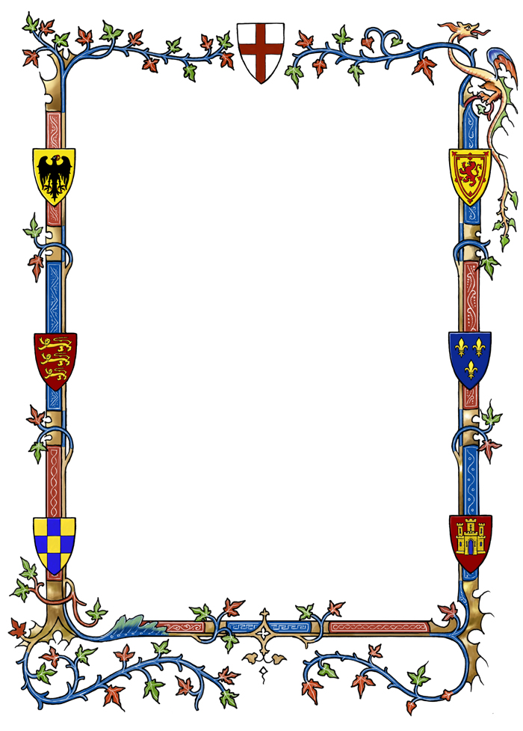

Our **mental maths focus** this half term will be:

Y3 - Link 2, 4, 8 x tables through doubling.

Y4 - Recognise and use ‘factor pairs and commutativity’ in mental calculations. (Factor pairs are pairs of numbers that multiply together to make a definite answer. For example 3 and 4 are a factor pair of 12 because 3 x 4 = 12. The children will be investigating different factor pairs of a number.)

Y3\4 Topic letter – Spring 2

This half term our myths and legends theme continues with some very exciting activities ahead!

**We look forward to learning:**

* About Roman Myths and Legends
* The famous legend of Arthur and the Knights of the Round Table
* Finding out more about knights by visiting the Royal Armouries Museum

**We are especially excited about:**

* Discovering more about some amazing creatures!
* Performing our play of Arthur’s Knights and the Dragon to the school and our families!

**Dates for the diary:**

27.2.14Reptile and Owl Company visiting school

6.3.14 World Book Day ‘Performance Poetry Project’

10/11.3.14 Parent-teacher interviews

12.3.14 Educational Visit to the Royal Armouries Museum, Leeds

21.3.14 Sports Relief

28.3.14 Final swimming lesson for Mr Mann’s class

31.3.14 Evening Production of ‘Arthur’s Knights and the Dragon’

1.4.14 Afternoon production of ‘Arthur’s Knights and the Dragon’

4.4.14 Easter Church Service/ Break up for Easter holidays

**Spelling groups**

Your child will be provided with a new set of spellings for the coming half term. List one will be tested next week (week beg. 3rd March)