**Key Stage 1 Newsletter**

[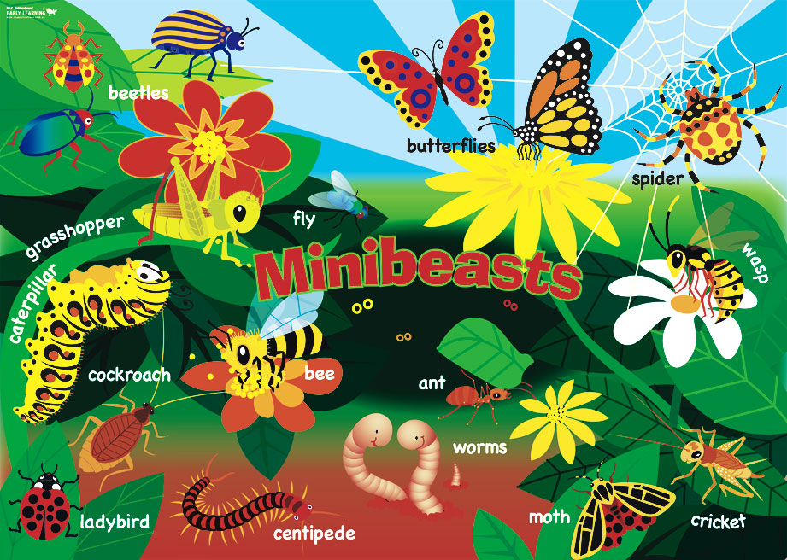](http://www.google.co.uk/url?sa=i&rct=j&q=&esrc=s&source=images&cd=&cad=rja&uact=8&docid=X4JX7S5TbutJ1M&tbnid=ZkHnIjLkjBo-nM:&ved=0CAUQjRw&url=http://www.teachersuperstore.com.au/product/early-years/early-years-theme-animals-posters/&ei=K9FDU67EKMiW0QWfpoD4Cw&bvm=bv.64367178,d.ZG4&psig=AFQjCNELJG4glEEjcsvVYmmkvYHd-IxCCQ&ust=1397039586715270)

**Summer 2014**

Welcome back to school. We hope that you have all had a fantastic Easter holiday and enjoyed the sunshine! This half term our topic is **‘Minibeasts**.’ We started this topic with an exciting minibeast art day on Thursday and a minibeast hunt today. We also hope to create a wormery and butterfly garden in the classrooms so that the children have the opportunity to see minibeats at work and have firsthand experience of the live cycle of a butterfly.

School

**P.E.**

This half term the children will participate in P.E on a Monday, Tuesday and Thursday. Please return your child’s P.E kit to school and ensure they have a warm top for outdoor sessions.

Please also ensure that you have returned your child’s water bottle to school.

**What will we be learning about?**

* To write non-fiction books and reports about

Minibeasts

To read a range of stories about minibeasts such as Superworm by Julia Donaldson.

* To make comparisons between minibeasts found in the UK and in other countries
* To find out the role minibeasts played in the Great Plague of 1665.
* To find out about plants and habitats in the local environment.
* To name a range of minibeasts and describe their body parts.
* To find out how minibeasts help the environment.
* To investigate the life cycle of minibeasts such as frogs, ladybirds and butterflies.
* To create minibeast artwork including work with clay.
* To sing a range of minibeast songs.

**Homework**

This half term we will not be sending a weekly homework in your child’s planner. If you would like to do any homework with your child please practise telling the time and also find out facts about Minibeasts.

We will continue to send home reading books, spellings to learn and Maths Facts books.