EYFS | Year 1 | Year 2 | Year 3 | Year 4 | Years 5/6
Understand 1:1 correspondence.  Know 1 more than numbers to 20.  Teacher modelled number lines in jumps of 1:  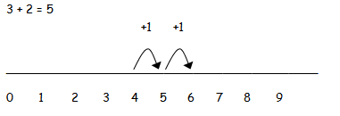  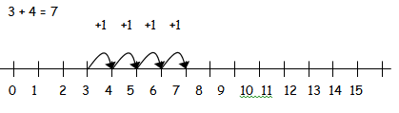 | Begin to record addition in jumps of 1 on a number line, including bridging.  Use a hundred square to count on 10 more and then multiples of 10.  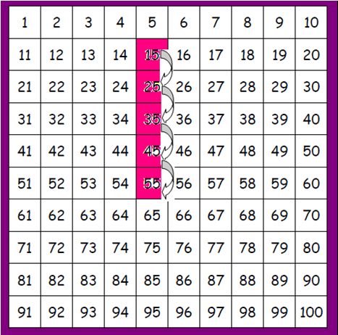  Begin to add near multiples, e.g. 9, 11, 19, 21 | First counting on in tens and ones:  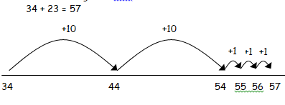  Then adding units in one jump and tens in on jump:  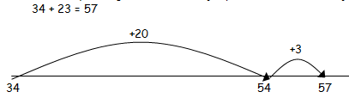  Then bridging through ten if that is more efficient:  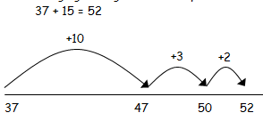  Adding near multiples. | Counting on from the largest number, regardless of the order of the calculation:  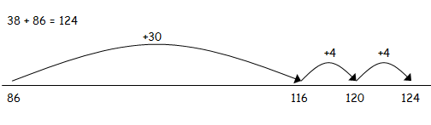  Compensation:  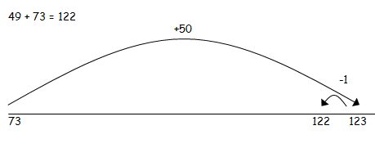  When place value is secure, begin to use a column method to add:  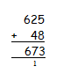  - TU + TU, no carrying  - TU + TU, carrying  - HTU + TU  - Carrying an increasing number of times within one calculation  - Several numbers with different numbers of digits | Extend the column method to four-digit numbers:  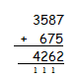  Using a column method, children will  - add several numbers with different numbers of digits;  - begin to add two or more decimal fractions with up to four digits and either one or two decimal places;  - know that decimal points should line up under each other, particularly when adding or subtracting mixed amounts, e.g. 401.2 + 26.85 + 0.71. | Consolidation and practise.
Addition

Subtraction
EYFS | Year 1 | Year 2 | Year 3 | Year 4 | Years 5/6
Understand 1:1 correspondence.  Know 1 less than numbers to 20.  Equipment to ‘take away’ and count how many remain.  Teacher-modelled number lines to count back:  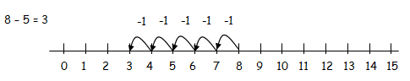 | Begin to find the difference by counting on:  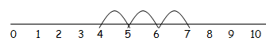  Use a hundred square to subtract 10 from any number.  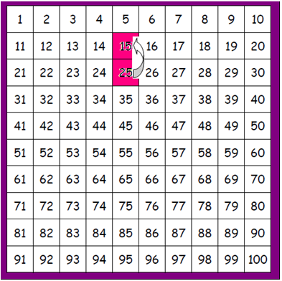 | Use a hundred square to subtract multiples of 10 from any number  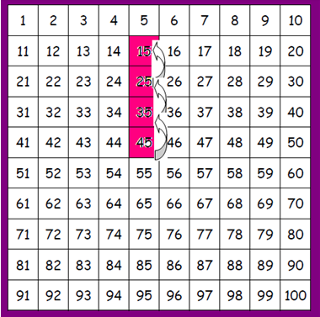  Use this approach to find near multiples, e.g. 9, 11, 19, 21  Counting back in tens and ones:  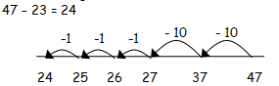  Subtracting tens and units in one jump:  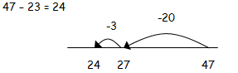  Then bridging through ten if that is more efficient:  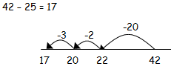  Finding the difference by counting on, e.g. 82-79 | Mental methods to develop for rounding (e.g. £20 - £7.99).  When place value is secure, begin to use a column method to subtract:  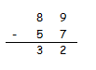  - TU - TU, no exchanging  - TU - TU, exchanging  - HTU - TU  - Exchanging an increasing number of times within one calculation  - Several numbers with different numbers of digits | Extend the column method to four-digit numbers:  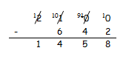  Using a column method, children will  - exchange across the calculation  - work with numbers to differing decimal places  - understand zero as a place-holder and understand the value of different digits in relation to this. | Consolidation and practise.

Multiplication
EYFS | Year 1 | Year 2 | Year 3 | Year 4 | Year 5 | Year 6
Practical activities grouping equal sets. | Find repeated addition, e.g. 3 x 5 = 5 + 5 + 5 = 15  Use arrays to model multiplication:  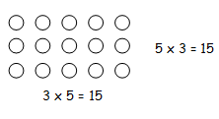 | Show repeated addition on a number line:  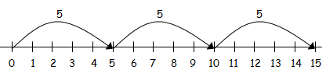  Begin to use times tables on a number line to show ‘chunks’:  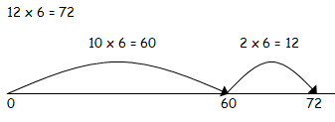  Know 2, 5 and 10 times tables | Use times tables on a number line to show ‘chunks’:  TU x U  Know 3, 4 and 8 times tables | Use a grid method to solve short multiplication (TU x U then HTU x U) calculations:  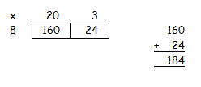  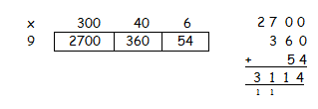  Know all times tables to 12 x 12 | Begin to develop long multiplication (TU x TU, then HTU x TU) using a grid method:  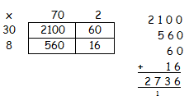  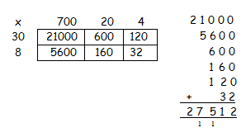  Using similar methods, calculate decimals up to 2 decimal places.  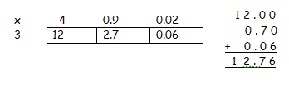 | Use a column method to multiply, following the same steps as grid method:  - TU x U  - HTU x U  - TU x TU  - HTU x TU  - Decimals  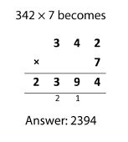  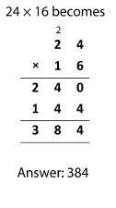  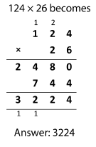

Division
EYFS | Year 1 | Year 2 | Year 3/4 | Year 5 | Year 6
Understand equal groups and sharing items out in play and problem solving. | Use jottings to support understanding of division, e.g. sharing sweets equally:  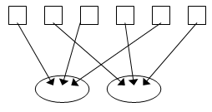 | Grouping, e.g. 6 sweets. How many people can have 2?  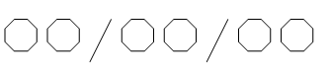  Counting on or counting back and counting the number of groups, using apparatus/ number line:  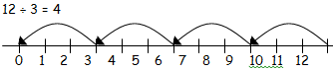 | Chunking multiples on a number line:  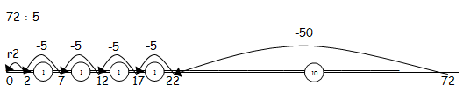  First without remainders, then with. | Introduction of bus shelter.  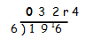  Following stages:  - TU ÷ U (short division)  - HTU ÷ U (short division)  - TU ÷ U with remainders  - Up to four digits with remainders  - Decimals | HTU ÷ TU (long division)  