SPORT AT ST OSWALD’S | Day - Year Group - Leader
Summer Term 2018
Ultimate Frisbee  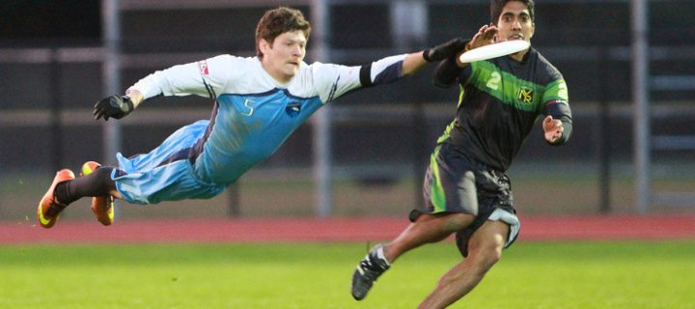 | Monday afterschool – KS2 – Josh Walker
KS1 Multi Sports | Tuesday afterschool – KS1  Mr Robinson with Mrs Heath
Football | Wednesday lunchtime – Year 3/4 – Sport Leaders/RWS  Friday lunchtime – Year 6 Sports Leaders
Tag Rugby  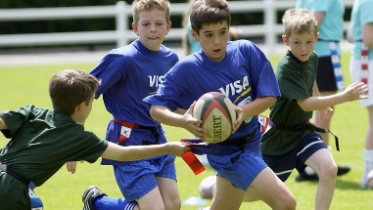 | Thursday lunchtime – Y5/6 – Martin and RWS
Dance | Wednesday lunchtime – Y5/6 - Miss Rowe  Wednesday afterschool – Y1/2 - Mrs Paley
Friday Fitness Club | Friday lunchtime –  KS1 and KS2 - Mr Waterfall-Smith
Sport leaders | Lunchtimes - Reception/KS1 children –  Year 6 sport leaders on KS1 playground

