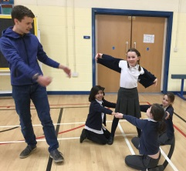
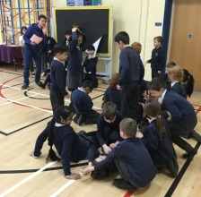
Last half term Y3/4 participated in an excellent drama workshop led by Julian Ollive from The Theatre Royal. Over half a day, we re-enacted Theseus and the Minotaur and explored different characters and themes. This was the springboard for writing our own version of the myth ‘with a twist’. In maths, we have been exploring multiplication. Your child has learned a written method for multiplication and is being encouraged to practice their times tables at home as much as possible.

In the short half-term ahead, we have so much to look forward to! Before the Easter celebrations begin we will be:
- Taking part, as one of 16 York schools, in the ‘York Writing Project’. The Y3/4 classes will be trialling a different writing process based around mythical creatures
- Visiting the Yorkshire Museum and York Art Gallery to take part in Ancient Greek workshops
- Sculpting our own Greek vases, choreographing an Olympic dance routine and investigating the water cycle!

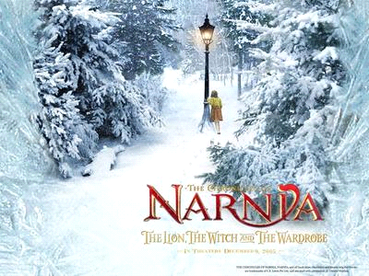
World Book Day is also fast approaching and we cannot wait to immerse ourselves in Narnia for the day. Our chosen book is ‘The Lion, the Witch and the Wardrobe’. All Y3/4 children are invited to arrive in any Narnia-related costume for the day.

To allow for our Greek trip and an exciting last day of term, we have rescheduled two of Miss Palfreeman’s class swimming lessons to after the Easter holidays. Please note there will be no swimming lessons on Friday 9th or Friday 23rd March

We look forward to seeing you all at parents’ evenings next week and hope you enjoy the chance to share your children’s fantastic learning in our classrooms and displayed around school. We are so proud of the progress being made by our Y3/4 pupils and the enthusiastic team of super-learners they have become.
Thank you for your continued support,
Y3/4 Team
Key Dates 22.2.18 - Whole school photograph 26/27.2.18 - Parents’ Evenings 1.3.18 - World Book Day
9.3.18 – Y3/4 Trip (late return 4.15pm) 23.3.18 - Last day of term

