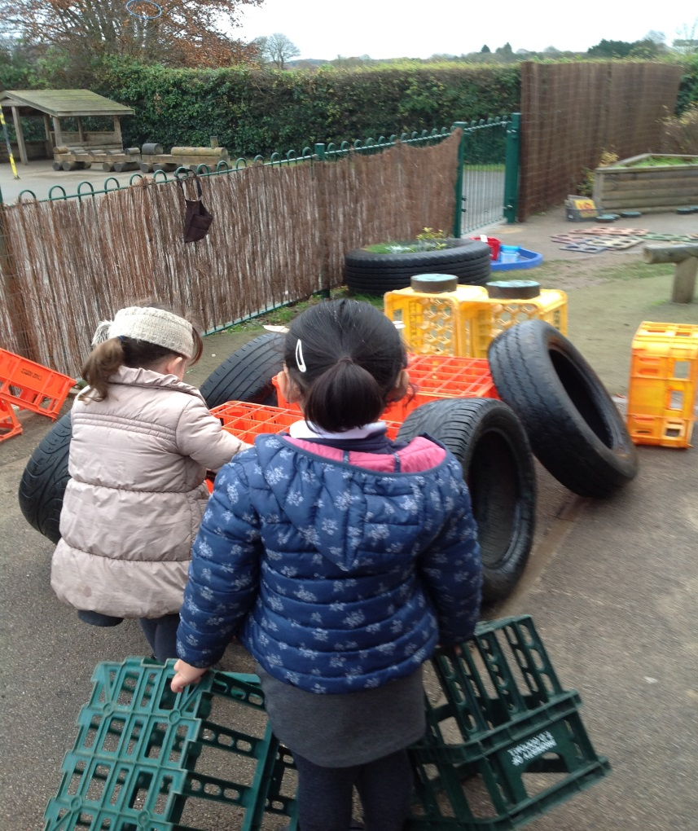
In Early Years we believe that children learn best through play. Play is highly engaging and very motivating and, when children are motivated and engaged, they are more likely to make good progress.
For this reason, we spend much of our day playing and interacting with the children, challenging their thinking, practising and consolidating what they already know and helping them to learn new skills and knowledge, within the context of the activities they choose to do.
Our environment is planned to support children in exploring new ideas as well as practising skills they already possess. We place equal value on both our indoor and outdoor environments. Our environment is changed regularly to maintain children’s involvement, to challenge them and support them to make progress and to take account of their interests. In all our provision, we consider the opportunities for children to practise key skills of reading, writing and maths.

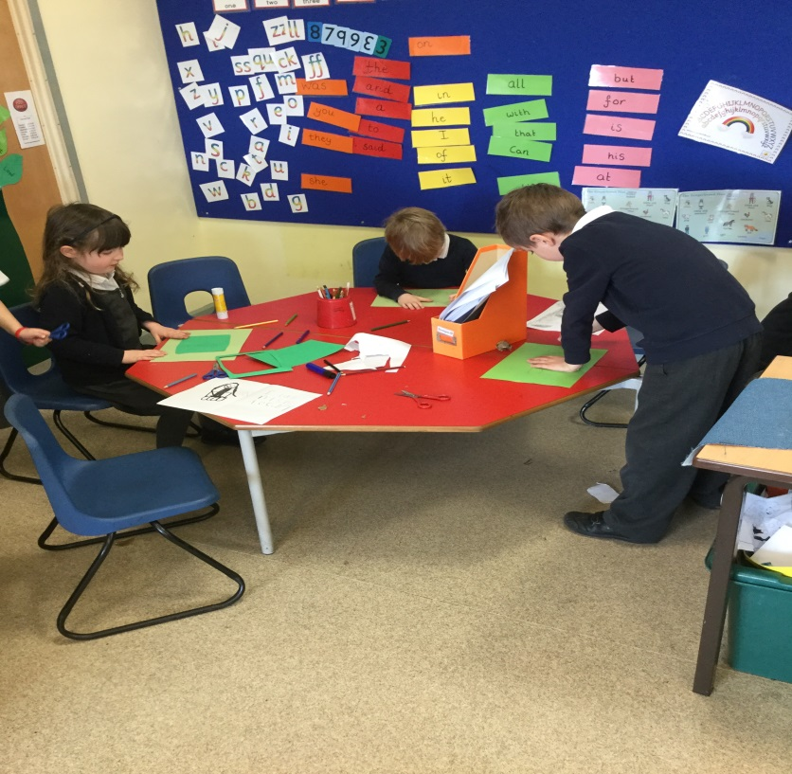

When it comes to deciding what experiences to provide next, we follow the children’s lead; resulting in diverse lines of enquiry rather than a pre-decided topic for the term. Popular themes include transport, animals, dinosaurs and princesses. Sometimes our learning path will be determined by a story the children have especially enjoyed and we also celebrate key festivals, such as Diwali and Christmas, throughout the year.

Each week we have a structured PE lesson to support children’s physical development and each class takes part in a Forest Schools session. “Forest schools” activities help children to learn about their natural environment, teach them to manage risk and help build confidence and team-working skills.
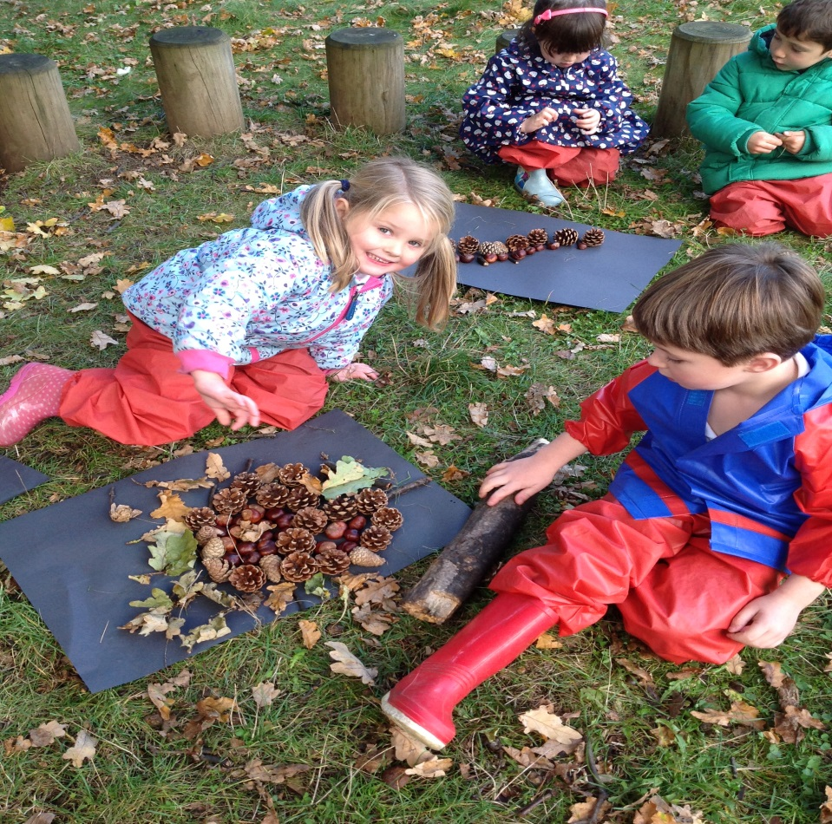

We firmly believe that all the children have the right to secure the basic skills they need for success in English and Maths. Each day we have short, structured sessions for teaching phonics, maths and handwriting. We also have daily sessions to support writing development. These are based around simple stories, poems and information books; where the children learn a text by heart and use their secure knowledge to help them write their own version.
Children read with an adult twice a week in a small group; where they are supported to develop their decoding skills as well as their understanding of texts. Children also write “News” every Monday. Each child has a weekly writing target and a weekly maths target and an adult will support them to meet this target through their play activities.

The Early Years curriculum is organised into seven areas of learning:
Prime Areas:
- Personal, Social and Emotional Development
  - Children are confident to speak to others and get on well with adults and other children. They follow rules and routines and are able to share and take turns.

- Communication and Language
  - Children listen to stories and other conversations. They follow simple instructions and speak confidently and fluently.

- Physical Development
  - Children are confident in using large and small equipment. They use tools and writing equipment safely and competently. They know how to keep themselves healthy.

Specific Areas:
- Literacy
  - Children read and understand simple sentences. They read common and irregular words and can talk about what they have read. Children write simple sentences that can be read by others. They can spell regular and irregular words.

- Maths
  - Children count and order numbers to 20. They can add numbers by counting on and can take numbers away by counting back. They can use objects to double and halve numbers and can share objects into groups. Children can talk about different shapes and can use everyday words to talk about money, time and size. They can copy and create patterns.

- Understanding the world
  - Children make observations about their local environment and the world around them. They learn about customs in different families and begin to understand how things change over time. They learn the purpose of different technologies and how they can support their learning and lives.

- Expressive arts and design
  - Children learn to express their ideas and feelings through music, dance, role play, art and design. They learn how to use a range of media and how to combine different media to achieve different effects. They use a range of tools and techniques competently.

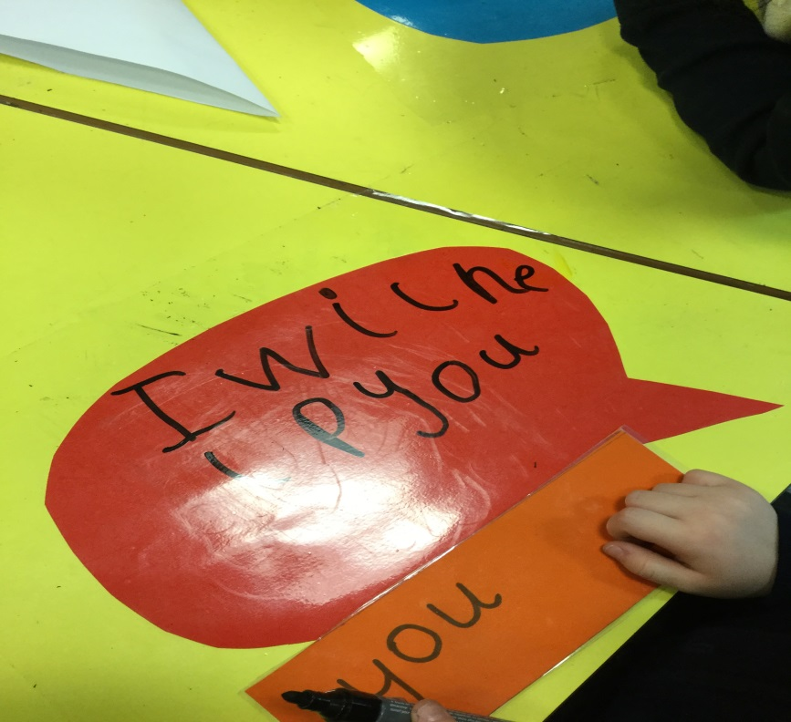

The children access all aspects of the curriculum every day and are supported to secure the skills they need in each area in a very personalised way.
We aim to keep you informed of our latest lines of enquiry through our displays, the children’s Learning Journeys and our “news” section on the website. If you have any questions about the way we work or how you can support your child, please don’t hesitate to ask.

