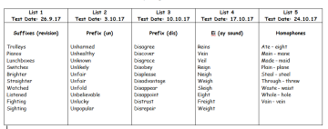
English
We ask that children read as often as possible, but at least 3 times per week. If your child’s planner is signed 3 times for the week, they will earn an owl stamp and a raffle ticket to put into the Y3/4 Prize Draw. Each Monday the raffle ticket winners will be announced!
Every child has now been given their spelling lists for the half term. These will be tested on a Tuesday morning and scores recorded in planners. All children have been given Y3/4 spellings, from the national curriculum, unless we felt that your child would benefit from more practice with earlier spelling patterns and rules.
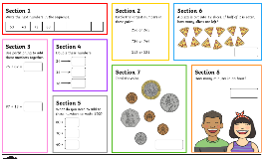
Maths
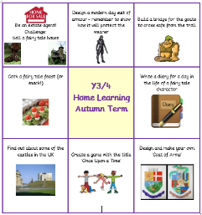
Your child will bring home a maths practice sheet each week. These are designed to help children to become more fluent in the key areas of maths and should take no more than 20 minutes to complete. They will be handed out and collected in each Monday.

Topic
Today your child has been given their Y3/4 home learning book and folder. Home learning activities will be fortnightly, topic-based tasks that we hope will be an enjoyable way for your child to extend their in-school learning. One task should be chosen from the chart and completed over 2-weeks, using 2 pages (1 double-page) of the home learning book. The due in date will be labelled inside each time.
We have included a letter for you to share with your child that explains this further. If you have any questions regarding any of the home learning tasks, please do not hesitate to ask!
Many thanks

Miss Ramsay, Mr Mann and Mrs Usher

Dear Pupil,
You will be given 2 weeks to complete each task from the chart above. You can complete the tasks in any order that you choose.
Do not use more than 2 pages of your homework book on any task.
You can be as creative with your tasks as you like. Use any colours or materials that you would like to. You can stick things in such as pictures and fold-out flaps.
Every fortnight, all the Y3/4 classes will share their home learning tasks in a gallery to share their super learning.
Each Monday lunchtime, a Y3/4 teacher will be in the ICT suite for ‘home learning club’ time. You can use the computers to complete your home learning task. Home learning club is a place where you can have help; borrow stationery and equipment; and even print out your work.
We cannot wait to share your home learning with you!
Miss Ramsay, Mr Mann and Mrs Usher

What do you need to know about home learning in Years 3 and 4?
Dear Pupil,
You will be given 2 weeks to complete each task from the chart above. You can complete the tasks in any order that you choose.
Do not use more than 2 pages of your homework book on any task.
You can be as creative with your tasks as you like. Use any colours or materials that you would like to. You can stick things in such as pictures and fold-out flaps.
Every fortnight, all the Y3/4 classes will share their home learning tasks in a gallery to share their super learning.
Each Monday lunchtime, a Y3/4 teacher will be in the ICT suite for ‘home learning club’ time. You can use the computers to complete your home learning task. Home learning club is a place where you can have help; borrow stationery and equipment; and even print out your work.
We cannot wait to share your home learning with you!
Miss Ramsay, Mr Mann and Mrs Usher

