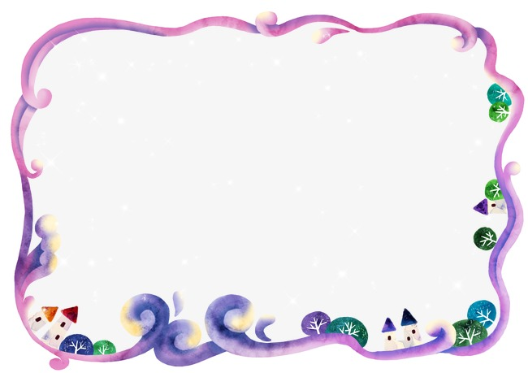
Welcome to Year 3/4!
Y3/4 Topic letter – Once Upon a Time
We are delighted with how well our new group of Year 3 & 4 children have settled in and the fantastic start they have made to the school year. We have all enjoyed a creative start to our new topic ‘Once Upon a Time’: making porridge; dancing like the Shoemaker’s elves and acting out the Pied Piper of Hamelin.

This term, we will be learning more about tales from the past, with a particular study of Knights and Castles.

Planners and Home Reading
Your child should now have a school planner and reading book appropriate to their reading level. In Y3/4, we encourage the children to read regularly (at least 3 times a week) at home and ask that you comment and sign each time you listen to your child read in the spaces provided within their planner. Planners and reading books will also be used in school daily and signed by the class teacher each week. If there is an urgent message that you would like your child’s class teacher to know about, please ask your child to hand their planner in as soon as they arrive in their classroom.

Home Learning
A letter will be sent home in the next few weeks to explain what homework will be set in Y3/4. For now, we are encouraging the children to throw themselves into their reading and have provided them with a book-banded book as well as offering a range of Y3/4 ‘recommended reads’. This term, every child who reads at least 3-times a week will earn an owl stamp and a raffle ticket for the weekly Y3/4 prize draw.

Open afternoon
You are warmly invited into Y3/4 on Wednesday afternoon between 3.15-4.15pm. This will give your child a chance to show you their new classroom and to meet their teacher. We hope to see you there!

Swimming Dates – letter to follow
Mr Mann’s class: Starting Monday 17th September
Miss Ramsay’s class: Starting Monday 14th January
Mrs Usher’s class: May start date to be confirmed

Many thanks,
Year 3/4 Team

