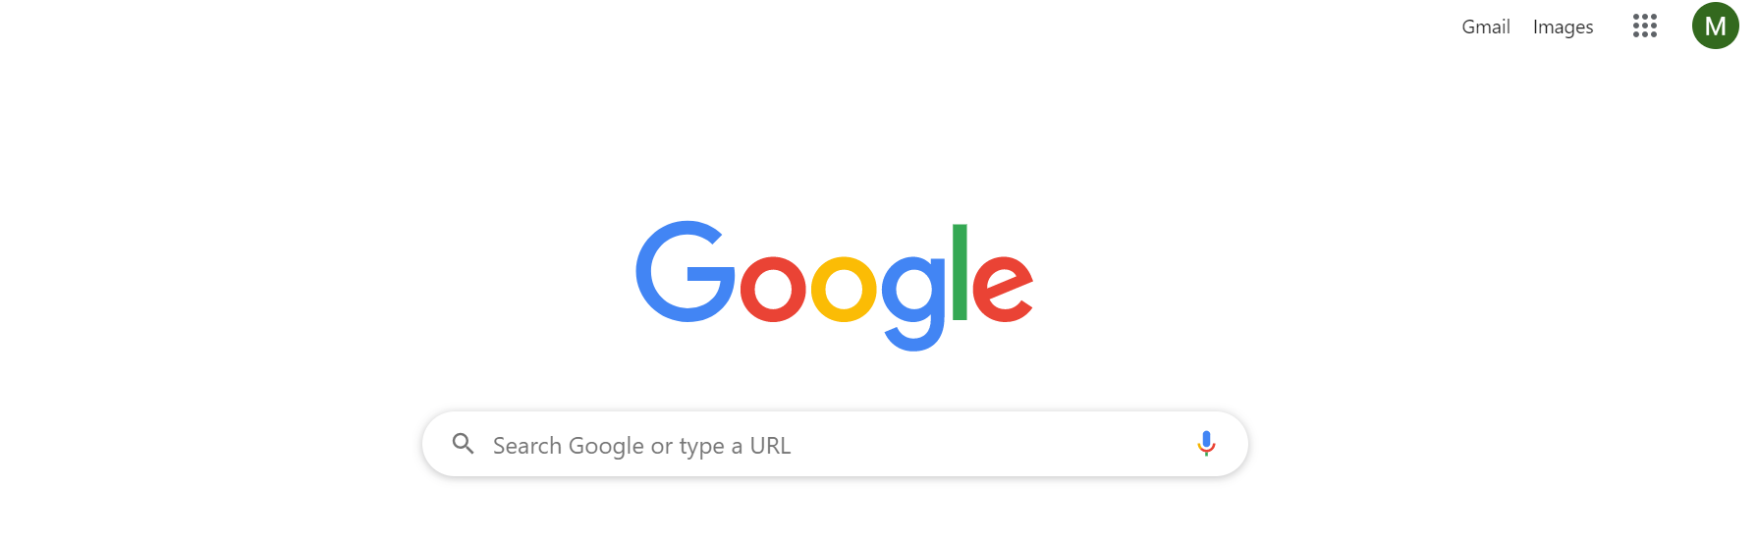
- Click the account user button if already logged in to Google Drive. If not, you can simply Google search ‘Google Drive’ and then press ‘sign in’.
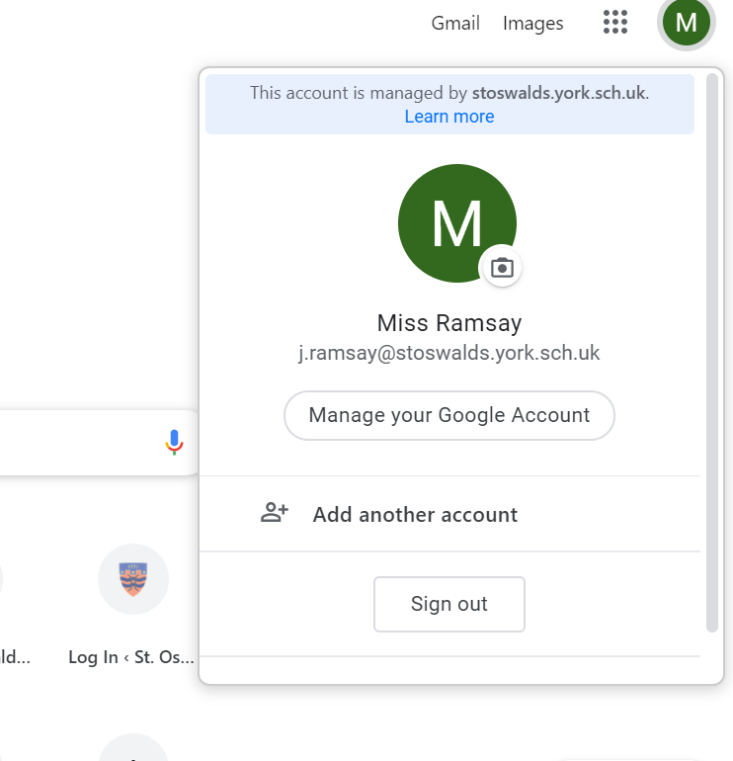

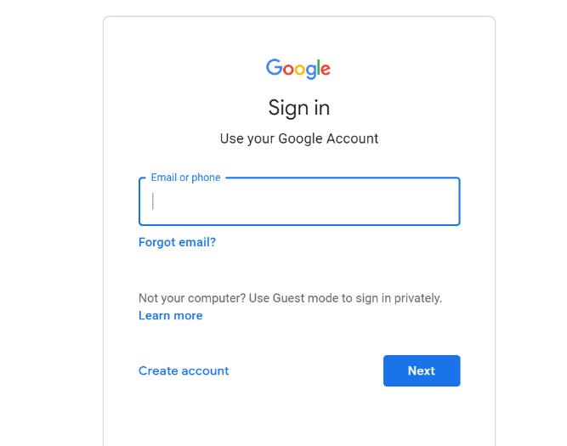
2. Enter your child’s school email address (this should be in their planner on a sticky label)

3. Once logged in, you can now access Google Classroom and Drive from the 9 dot menu

