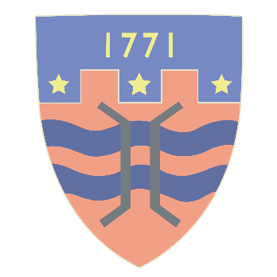

St Oswald’s CE Primary School
Learning for all, caring for each other, preparing for the future
Let us encourage one another – Hebrews 10.25
Pupil results at end of Key Stage 2, 2022
In 2022, the attainment of 45 pupils in Year 6 was formally assessed against the requirements of the national curriculum. Attainment in Writing was based on Teacher Assessment, while most pupils took standardized national tests (SATs) in Reading, Maths and Grammar, Punctuation & Spelling in May 2022.
Pupils’ raw scores in the SATs tests were converted to a ‘scaled score’. Any pupil who achieved a scaled score of 100 or more was deemed to have ‘achieved the expected standard’. Pupils with scaled scores of 110 or above were deemed to have achieved a ‘high level of attainment’.
**There were no national tests in 2020 or 2021, following school closures related to the Covid pandemic. Data for teacher assessments, based on tests using previous test papers, has been given for these years.
Percentage of pupils at St Oswald’s achieving the expected standard or above:
 | Reading | Writing | Maths | Reading, Writing & Maths
2022 | 96% | 93% | 93% | 87%
**2021 | 87% | 82% | 84% | 76%
**2020 | 88% | 81% | 77% | 73%
2019 | 82% | 84% | 86% | 73%
2018 | 84% | 74% | 70% | 58%

Percentage of pupils at St Oswald’s achieving a high level of attainment:
 | Reading | Writing | Maths | Reading, Writing & Maths
2022 | 53% | 29% | 38% | 20%
**2021 | 42% | 18% | 31% | 16%
**2020 | 48% | 17% | 27% | 13%
2019 | 34% | 23% | 41% | 16%
2018 | 37% | 5% | 16% | 2%

Average ‘scaled score’ in the tests:
 | Reading | Maths | Grammar, Punctuation and Spelling
2022 | 113 | 108 | 111
**2021 | 107 | 106 | 102
**2020 | 108 | 105 | 106
2019 | 107 | 108 | 108
2018 | 107 | 103 | 107
2017 | 106 | 104 | 107
2016 | 102 | 102 | 102

Progress is measured by comparing each pupil’s attainment at end of Key Stage 1 with their attainment at end of Key Stage 2. This gives each pupil a progress score, which is then used to create a school level progress score.
Average progress KS1-KS2
 | Reading | Writing | Maths
2022 | +2.3 | +1.6 | +0.5
2019 | +1.8 | +0.2 | +2.0
2018 | +0.5 | -3.8 | -1.9
2017 | +0.3 | -3.0 | -1.7
2016 | -0.9 | -3.0 | -3.1
(Progress measures are not available for 2020 and 2021)
Progress scores measure the progress made from the end of Key Stage 1 to the end of Key Stage 2.
- They are centered around 0, with most schools within the range of -5 to +5.
- A score of 0 means pupils in this school on average do about as well at KS2 as those with similar prior attainment nationally.
- A positive score means pupils in this school on average do better at KS2 as those with similar prior attainment nationally.
- A negative score means pupils in this school on average do worse at KS2 than those with similar prior attainment nationally.
- A negative score does not mean that pupils did not make any progress, rather it means they made less progress than other pupils nationally with similar starting points.

