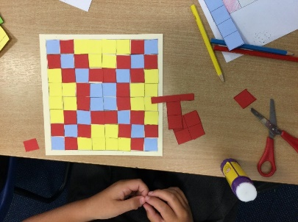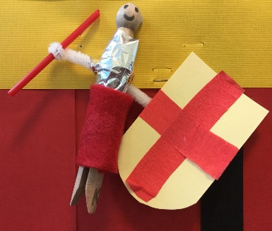**Year 3/4 Newsletter**

**Autumn 1**

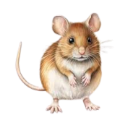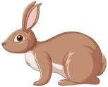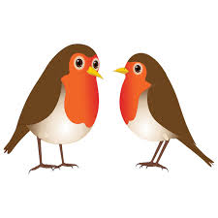

|  |  |
| --- | --- |
| **So far this term…**  The children have settled in well to their new year groups and classes and have been having fantastic fun learning about the Romans. The visitor we had in school last week was brilliant, the children all enjoyed themselves and learnt lots.  In Science we have been learning about Forces and Magnets and setting up our own investigations and in English we are about to write a Visitors Guide to Ancient Rome.  The children all seem to be enjoying choosing their own books to read at home and in school and have been making good use of the new Reading Area. | |
| **Don’t Forget…**  The Home Learning Project is due in on **Friday 20th October**. It can be anything at all about Romans – it can also be presented in any form (PPT, poster, artwork, model etc)  Our Home Learning Gallery, when all parents/carers are invited in to view our work, is on 3.15pm **Monday 23rd October** | **Important Dates**  October 6th – Flu vaccinations  October 18th – Individual and sibling photos  October 27th October – break for half term  November 21st and 22nd – Parents Evenings  November 23rd – 2.30pm Y3/4 Collective Worship in St Oswald’s Church |
| **Swimming**  Mrs Haxby’s Dormice enjoyed their trip to York Sport for swimming lessons last week. The other swimming dates for Dormice class are 29th Oct, 6th, 13th and 20th Nov. After half term it will be Mr Lloyd’s Rabbits class that will go swimming, more info to follow. | |
| **Finally…**  Feel free to come and have a look in the cloakroom at the end of the day for any lost items. We already have quite a pile of unclaimed jumpers and cardigans!  There are still a few children who do not have a full PE kit in school. Please make sure this is brought in as soon as possible. If you need any help with this, please speak to Mr Lloyd.  We would also like to give a gentle reminder that all snacks must be either a piece of fruit or a plain cereal bar. Unhealthy snacks such as crisps, chocolate bars, cakes etc. should not be brought in as a playtime snack. | |